М.Б.О.У.Ц.О №13 им. Е.Н. Волкова «Барсуковская средняя общеобразовательная школа»

Урок на тему « Путешествие по Британии»
»
8 класс
Учитель: Круглик Л. А. Тула
1. Фонетическая зарядка.
So, we have decided to travel. Modern life is impossible without travelling.
Repeat after me.
- Leeds
- Humpton Court.
- Brighton.
- Stradfort- upon- Avon
- National Gallery.
- Trafalgar Square
- Oxford
- Buckingham Palace.
- London.

- Westminster.
- The Tower of London.
- Stonehenge.
- Salizberry.
- The Houses of Parliament.
- Big Ben
- The United Kingdom

Открытый урок по теме: « Путешествие по Британии»
Цели урока:
. развитие иноязычной коммуникативной компетенции;
. речевая компетенция- совершенствование коммуникативных
умений в четырех основных видах речевой деятельности; развитие
умения вести диалог с обменом мнениями.
. языковая компетенция-систематизация раннее изученного
материала; овладение новыми языковыми средствами в
соответствии с темой урока.
. социокультурная компетенция -увеличение объёма знаний о
жизни своих зарубежных сверстников в англоязычных странах .
учебно-познавательная компетенция- развитие общих и специальных учебных умений , позволяющих совершенствовать учебную деятельность по овладению английским языком, удовлетворять с его помощью познавательные интересы в других областях знаний.
Воспитание гражданской ответственности
за своё поведение и поступки; развитие способности и готовности к самоопределению учащихся; формированию у них гражданственности, осознание обязанностей по отношению к государству, обществу.

Оборудование урока: видовые картинки, таблицы, карточки, пословицы, кассета.
The theme of our lesson is Travelling to Britain .
Travelling abroad is not just visiting new places , but also meeting new people.
- To get the most of the travelling you should know a lot.
- Of course you should know how to pronounce words correctly
- And speak without mistakes
- But what is more important you should know how to communicate with people from other countries.
Today we shall try to learn how to communicate, speak about what the British are like, see the film Travelling to Edinburge.
2. What would you visit in Britain.
I would visit the Tower of London. It was a fortress, a royal palace , and
later a prison. It is a museum now.
There are interesting collections in the Tower of London.
The ravens are an other famous sight. The legend says that without them
the tower will fall. The Raven Master is the person who gives them
food.
It is one of the most ancient buildings of London. It was founded in the
11th century by William the Conqueror.
The grey stones of the Tower could tell terrible stories of violence and
injusties. It was here that Thomas More, the greatest humanist was
falsely accused and executed. Among famous prisoners at the Tower
were Henry 8 s wives Anna Boleyn and Catherine Howard.
When Queen Elizabeth was a princess she was sent to Tower by Mary
Tudor (Bloody Mary).
I would like to visit Westminster Abbey.
It is a royal church. Here you can see the tombs of many British kings
and queens and o the famous people.
If you go past the magnificent tombstones of kings and queens some made of gold you will come to the Poets Comer. There are many of the greatest writers are buried here- Geoffrey Chaucer, Samuel Johnson, Charles Dickens, Thomas Hardy.
There are memorials to Willam Shakespeare, Robert Burns and Byron. Here in the Abbey there is also the grave of the Unknown Warrior, a symbol of nations grief.
The inscription on the tomb reads- Beneath this stone rests the body of a British Warrior unknown by name or rank brought from France to lie among the most illustrious of the land....
I would visit Buckingham Palace. It is the London home of the Queen Elizabeth, the second. When the flag is flying on the top she is at home.
The National Gallery has the fine collection of European paintings. The modern collections includes the paintings of Pablo Picasso, Salvador Dali, Peter Blake.
I would visit Trafalgar Square. On the column in the centre there is a statue of Admiral Nelson, who defeated the French at the battle of Trafalgar in 1895.
There you see the Houses of Parliament and Big Ben. The Houses of Parliament is the seat of the British government. Big Ben is one of the most famous clock in the world.
I would like to visit Stradfort -upon- Avon. The greatest play writer and poet William Shakespeare was born there.
I would like to visit Stonehenge.
The great stone monument of Stonehenge is the best known monument in
Britain. It has stood on Salisbury Plain about 4 000 years.
At one time people thought that Stonehenge was a Druid temple
There have been many different theories. So that the stones could be
used as a calendar.
There are also some local legends. One of them tells that Stonehenge
was build by the devil in a single night. He carried huge stones. As he
worked he laugh at himself. That will make people think. They will
never know how the stones came here. But a friar saw him. In his turn
the devil saw the friar too and he threw a stone at him. This stone is
known as the heel stone and it is lying by the side of the road.
Знакомство с традициями Великобритании.
So you should know how to communicate . We must know a lot.
- What is the full name of the country situated on the British Isles?
- Which four parts does the United Kingdom consist on?
- What is the name of the British flag?
- Most British people speak English but Gaelic is also spoken in the West and North of Scotland and in the Northen Ireland. Welsh is spoken in Wales.
- Kilt is a traditional dress in Great Britain. What interesting facts about kilt do you know?
During the first World War Scottish soldiers still wore kilts Well- known for their bravery and they terrified the enemy the Germans called them witches.
6 What the British are like? Trying to explain what the British are like is the same as attempting to describe the difference between Europe and Asia in one sentence. But let us try anyway.
They like forming queues It is their national characteristic British like forming queues they may get really annoyed with people who don' t wait for their turn in the queue , such people are called queue-jumpers. Сценка.
7Are the British great smokers?
There is no more smoking on the London underground, in the cinemas, theatres, buses.
8. Are pubs an important part of the British life?
Pubs are an important part of British life. People, especially men go to the pub to relax, meet friends and sometimes to do business.
Сценка « В баре» Children are not allowed to visit pubs under the age of 14.
Кассета.
When in Britain do not afraid to show that you do not understand.
Always ask people for explanation.
Lets act out a dialogue.
- Excuse me. Could you tell me . Where the post- office is?
- Um. Go to blocks and turn right. Its near the bank.
- Sorry, can you say it again slowly, please?
- First go two blocks Then turn right. The post-office is near the bank.
- Excuse me.
- I am a foreigner
- Oh, now I see
- Thank you.
Cultural note.
If you do not understand what someone says
- interrupt people politely.
- Excuse me, I don't understand
- Sorry, What does it mean?
- I am sorry. Can you say it again.?
E) Use questions- words/
F) What...?
G)How...?
H)Why.../
When..?
I) Where..?
The following task is «Guess who it was» Стр. 1 из 1
j
The following task is «Guess who it was»
- He was one of the greatest writers. He was born in Stratford-upon-Avon. England, where he received a classical education.
- When he was six years old, his parents sent the boy to England where he attended school. At the age of 17 he returned to India, where he worked as a newspaper reporter for several years.
He is best known for his works for children, especially» The Jungle
book» He was awarded the Nobel Prize for literature in 1907.
3. A Scottish writer was born in Edinburgh. He learned Italian, Spanish,
French. Ivanhoe, the Talisman are his well known novels. His works are translated into many languages in the world.
(Walter Scott).
4.He is an English writer .He was born in 1856 He wrote a lot of adventure books «King Solomon’s mines», «The people of the mist»
(Henry Haggard)
5.He was born in 1660 in London in a rich family. His main book is. «Robinson Crusoe».This book is about adventures. The main characters are Robinson, Friday.(Daniel Defoe).
6.At the age of 18 he married Anne Hathaway, and they had three children. In London he became an actor and began to write plays. He wrote plays for the famous Globe Theatre. He achieved great recognition during his life time. He wrote three types of plays - histories, comedies, and tragedies. He is acknowledged as one of the greatest writers of all time, and has remained popular with readers around the world.
7. He was born in 1^{л} 850 in Great Britain in a rich family His main book is Treasure Ireland. The main heroes of this book are Jim Hawking, John Silver.. (Robert Louis Stevenson)
file://C:\Documents and Settings\EBreinrii\MoH документыУГпе following task is.htm 29.03.2009
Try your hand at this quiz.
Part 1. Choose the correct answer for each question.
l. This is a symbol of the British nation. His name is-
- Uncle Sam
- John Bill
- Winston Churchill
2.The capital of Northern Ireland is... A)Dublin B)Cardiff C) Belfast.
3. Ben Nevis is...
- famous footballer
- a sort of whiskey
C) a mountain.
4. The national currency of the U. K. is-
A).the dollar B). the pound C). euro 5The most popular sport in Britain is-
- ice- hockey
- baseball
C) football
6.Britain national drink is-
A)tea
B) coca- cola
C) coffee
7.The British flag is -
A) the Union Jack B) Stars and Stripes C)Maple Leaf.
8. The mysterious Lock Ness Monster is from-A) Wales B)Ireland C) Scotland.
Английские пословицы о путешествии ( на доске висят плакаты, состоящие из двух частей) Find the other half of these English proverbs. Every country has....
East or west
There is no place
The wider we travel
It’s customs. The welcome home. Home is the best Like home.
»
Домашнее задание:
Now we shall watch the film «Travelling to Britain»(проcмотp фильма
«Путешествие по Британии» Учащимся даётся задание пересказать
содержание фильма к следующему уроку,
Заключительное слово учителя:
If there is rightness in the soul
There will be beauty in the person
If there is beauty in the person
There will be harmony at home.
If there is harmony at home
There will be order in the nation
If there is order in the nation
There will be peace in the world.
I wish you all the happiness in the world,
May all your dreams come true,
And I wish you to travel not only to Britain but all over the world.
Quiz
- Try your hand at this quiz
- Choose the correct answer
The capital of the U .K...
a) Dublin b) Cardiff c) London
- The British flag is often called...
a) the Stars and Stripes, b) the Union Jack c) the Maple Leaf.
The National Gallery J
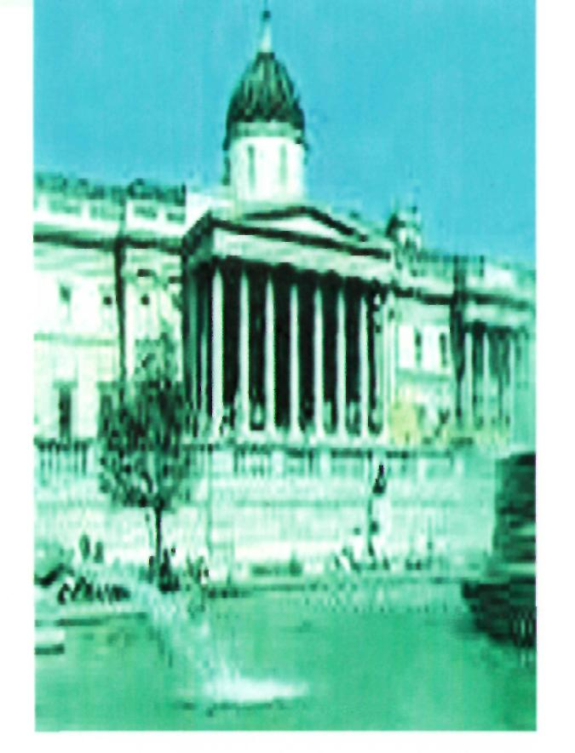
It has been in this building since 1838. The National Gallery contains a rich collection representing works of all European schools of painting existed between the 13 th and the 19 th centuries.
THE CHANGING OF THE
GUARDS CEREMONY

Outside Buckingham Palace you can see guardsmen dressed in the bright red uniforms and bearskin hats. They protect the Queen. It is the Changing of the Guards Ceremony and it dates back to 1660.
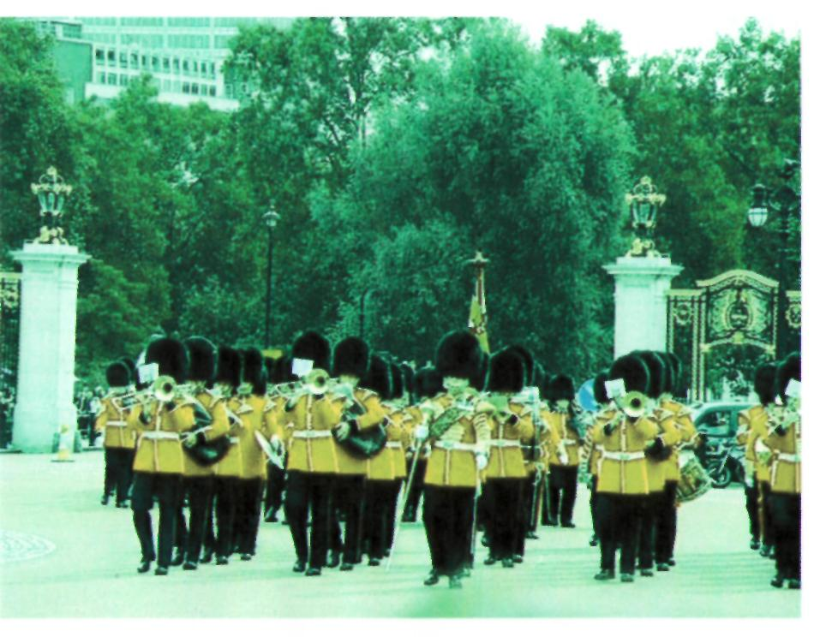

Tower of Bridge
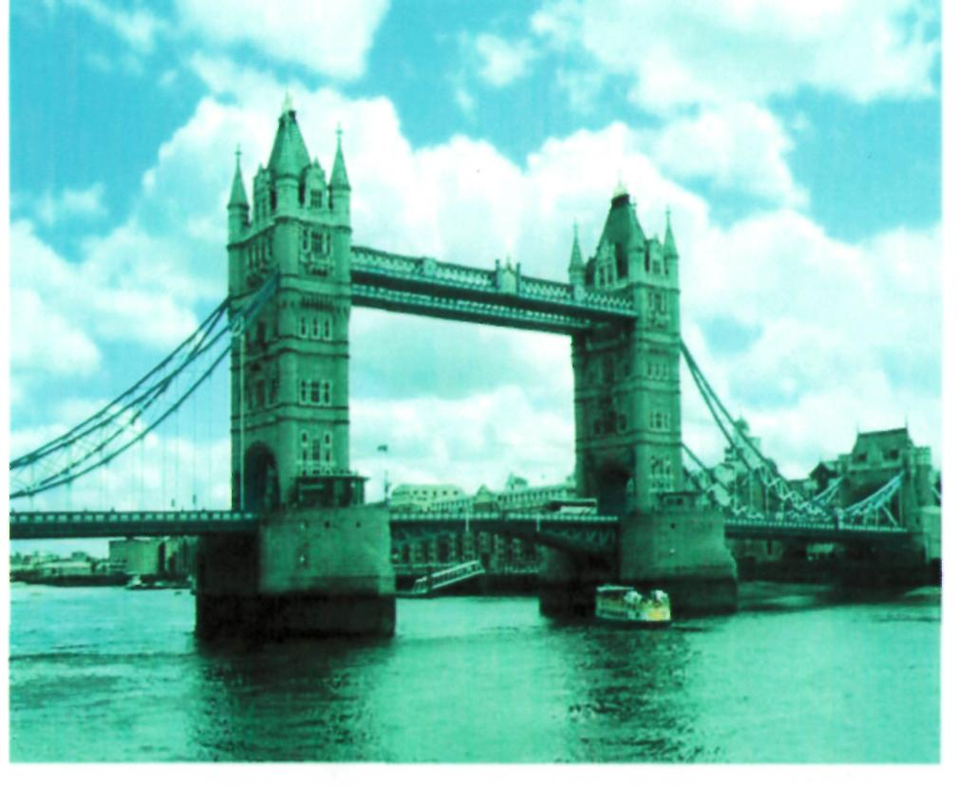
Now you can see Tower Bridge over the river Thames -a masterpiece of engineering skill.
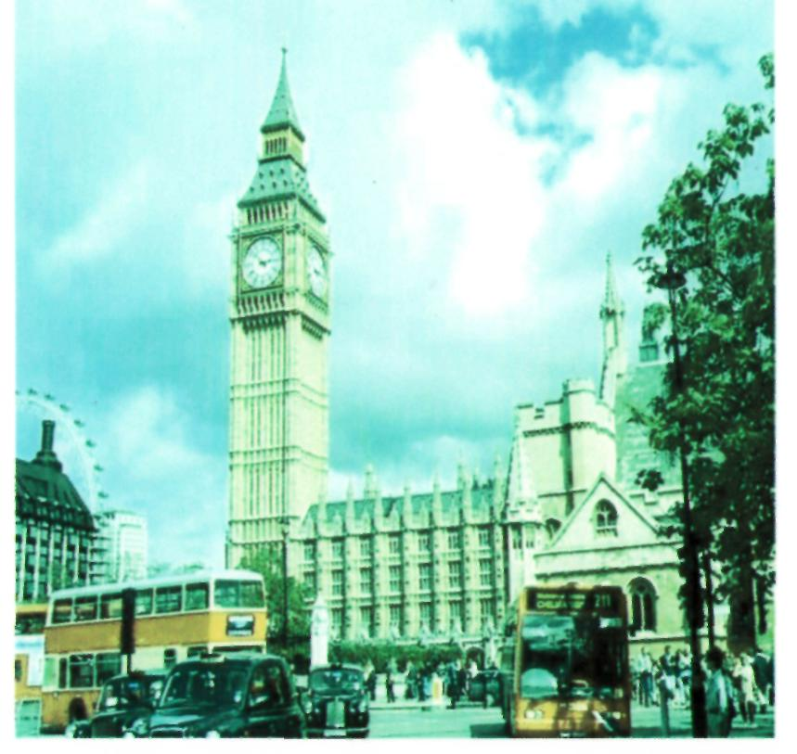
The Houses of Parliament is the seat of the British government. Big Ben is one of the most famous clocks in the world. The clock with its bell is named after Sir .Benjamin Hall, the chief Commissioner of Works when the Houses of Parlia ment were rebuild in 1850. He was a very tall and stout man. His nickname was «Big Ben»
The Houses of Parliament and Big Ben
St.Pauls Cathedral

- It is one of the finest
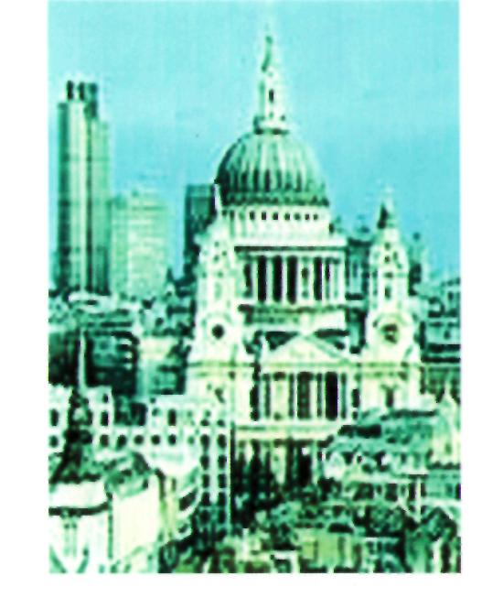
- pieces of architecture in Europe, the work of the famous architect
- Sir.Christopher Wren. The interior of the Cathedral is very beautiful. It is full of monuments.

Now we are at Buckingham Palace
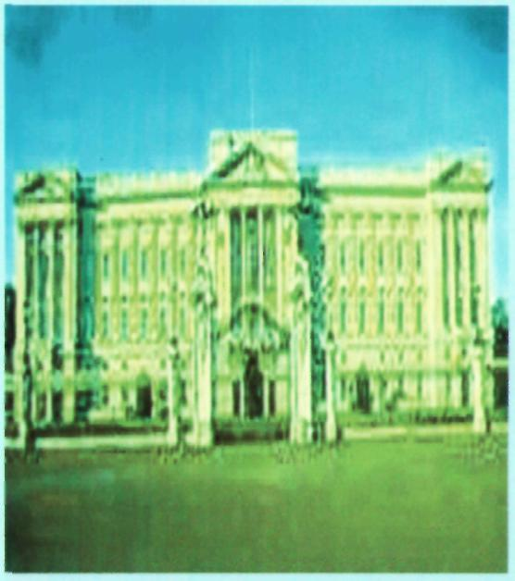
It is the London home of the Queen. When the flag is flying on the top she is at home.
Quiz
- The national currency of the U.K…
a) the euro b) the dollar c) the pound.
- The most popular sport in Britain...
a) ice - hockey; b) football; c) baseball.
- The changing of the Guards Ceremony Dates...
a)1900 b)1600 c)1800.
9. The Beatles started in –
A) London B) Liverpool C) Birmingham
10. The kilt is-
A) a shirt B) a skirt D) a pair of trousers

11. Stonehenge is about years old.
A) 40 B) 400 C) 4000 D)

12.Children are allowed into pubs
A) at age of 12 B) at age of l4 C) at age of 18

13. What place is the official home of the queen
A) the Tower B) Buckingham Palace
C)ST. Paul Cathedral

14. What is the name of the poet who was called the Father of English
poetry? A) W. Shakespeare
B) George Byron C) G. Chaucer

15. What holiday is celebrated in Britain on the 25 th of December?
- St. Valentine day
- Mothers day
- Christmas

