Lesson plan

Topic “Famous actors and actresses”

Objectives:

to practise listening skills;

to practise reading and speaking about famous actors;

to practise question forms;

to discuss the problem of being famous, the advantages and disadvantages of being famous

Age group: teenagers

Level A2

Materials:

O. V. Afanasyeva, I. V. Mikheeva “Rainbow”, audio recording, students` workouts

Procedure

1. Introduce the topic. The teacher shows pictures of famous actors and actresses and students try to guess their names. If they fail they ask questions

What is his name?

What is his occupation?

Is he an American actor?

What films did he star in?

The teacher asks what all these people have in common and if the students can think of the topic of the lesson.

1. Warm up. Who is your favourite actor? What are his/her best films? What kind of film is it?(science fiction, drama, comedy, thriller, criminal, action, biography…)
2. Listening **Before listening**. Students watch a short video from Shrek with Puss in Boots. Do you know the cartoon? Do you recognize the character? What actor gave his voice to Puss in Boots? (Antonio Banderas). What do you know about the actor?

Open your books on page 37 and find exercise 1. You are going to listen to the story about Antonio Banderas and do the task.

Before listening try to predict the answers

After listeningstudents do the task and **count their points.**

Then they answer the teacher`s questions.

When and where was Banderas born?

What were his parents` occupations?

How did he start his career?

What are his best films? (Philadelphia, Evita, The interview with a vampire, The mask of Zorro.

What kind of person is he? (kind, clever and optimistic)

1. Reading. Jigsaw reading.

Vocabulary, pronunciation

You will work in groups of five. Each group will read about one famous actor. Remember the information, don`t write anything. To get information about other actors go to other groups and ask them questions. Complete the chart.

Teacher asks questions.

1. Discussion. Is it good to be famous? Group work. Optimists and pessimists. Wordcloud. Do you want to be an actor?
2. Students count the points and see their results

**Students`workouts**

**Famous actors and actresses**

1. Listening. Antonio Banderas.
2. ___ 2._____ 3. _____ 4.______ 5. _______

My points __________(from 5)

1. Reading. Some famous actors.

Complete the chart. Get necessary information from your card or from your classmates.

|  |  |  |  |
| --- | --- | --- | --- |
| Name | The place and the year of birth | The films he/she starred in | Interesting facts |
| Charlie Chaplin |  |  |  |
| Emilia Clarke |  |  |  |
| Yuri Nickulin |  |  |  |

My points_____________(from 9)

1. Is it good to be famous?

|  |  |
| --- | --- |
| Good things | Bad things |
|  |  |
|  |  |

My points __________(from 2)

Total ______________

16-14- excellent! 5!

11-13 – good! 4!

8-10 – could be better… 3

0-7 – try again

**Listening (script)**

Antonio Banderas was born in Spain in 1960 in the family of a police officer and a school teacher. As a schoolboy Antonio wanted to become a football player but his sports career was over after he`d hurt his foot. Then the boy began to take drama classes and soon understood that he`d love acting. At 15 he worked at the theatre in Malaga moving the furniture and cleaning the floor. Sometimes he performed very small roles. Later he worked in other theatres. Soon the famous film director invited Banderas to act in his film. But when Banderas began working in Hollywood he had a big problem as he didn`t speak a word if English and had to learn the lines phonetically. Since that time his English has become perfect. His best films probably are Philadelphia, Evita and the Mask of Zorro. After “The Interview with a Vampire” he won the hearts of women in many countries of the world. In Evita he sang the songs himself. In Shrek Banderas gave the Puss in Boots his voice both in English and in Spanish versions.

Antonio`s friends say that he is kind, clever and optimistic. He loves his family and Spain, his homeland.

**Jigsaw reading**

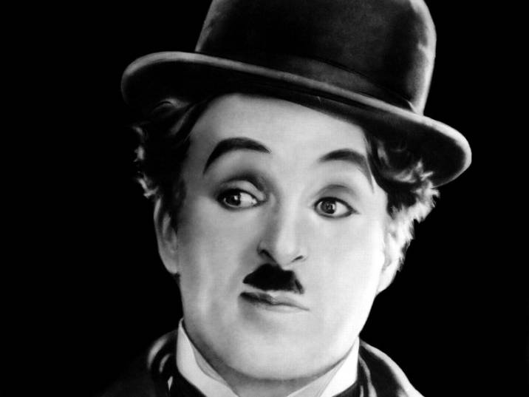

Charlie Chaplin

He was born in 1889 in England and lived a long life. He was a film

actor and director who worked a lot in the USA in silent black-and-white

comedy films. His favourite role was that of a tramp* wearing

funny clothes and walking in a funny way. Films “The Gold Rush”*, “City Lights”, “The great dictator”, “The Kid” won a lot of awards. During his life he was very popular with the public. He died in 1977.

“The Gold Rush” – “Золотая лихорадка”

A tramp – бродяга



Angelina Jolie

Angelina Jolie is an American actress, filmmaker, humanitarian. The actress was born in Los Angeles, California. Both her parents were actors. As a child, she often watched films with her mother and got interested in acting. Jolie started to act professionally at the age of 16.

The film “Lara Croft: Tomb Raider” (2001) made her an international superstar. Angelina was given awards for films “The tourist”, “Gia”, “First they killed my father”. By 2008, Jolie was the highest-paid actress in Hollywood, earning $15–$20 million per film. Jolie has six children: three sons and three daughters.

“Tomb Raider” – расхититель гробниц

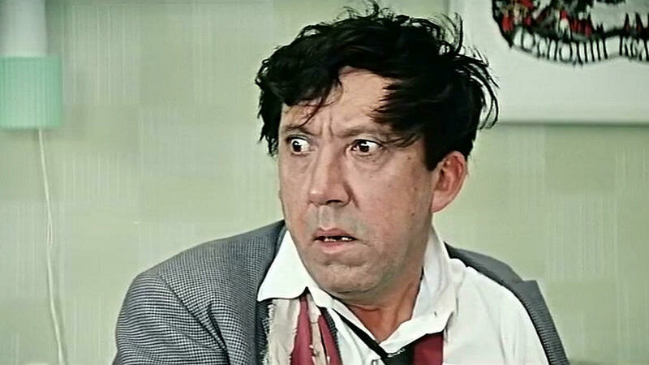

Yuri Nickulin

This Russian actor was born in 1921. He was at the front during the

Second World War. Since 1950 he began to work in the circus as a

clown. He became a popular film actor in his country. A lot of people

remember him for his comic and tragicomic parts. He is particularly well known for his role in “Dog Barbos and Unusual Cross”, “Operation Y and Other Shurik's Adventures”.