Мероприятие, посвященное традиции нашей страны Дню семьи – дню святых Петра и Февроньи
Цели: формирование умения и навыков монологической и диалогической речи;
развитие лексических навыков говорения; знакомство с историей и традициями праздника и православных День семьи – день святых Петра и Февроньи

T: Dear boys and girls. I am happy and glad to begin our lesson devoted to lovely
Russian holiday The day of family, love and fidelity , The Russian saints Pyotr and Fevroniya
Официально, праздник День влюбленных, в православии носит название – День семьи, любви и верности, Да, в России есть свой праздник, который все влюбленные могут с полным правом считать своим днем - Днем влюбленных. В нашей стране официально этот праздник называется The day of family, love and fidelity or Family day – the day of saints Peter and Fevronia.

Task 1. Warming-up
T: Listen to the statements carefully and try to give a short answer.
1. A flower which helps to find an answer to the question: Does he love or not? (chamomile).
2. Before a date/rendezvous you should look into the (mirror).
3. Reliable camouflage for the woman (cosmetics)
4. Cupid’s sharpness (an arrow).
5. The place of residence of the sweethearts (Paradise).
6. The opponent in love is (adversary).
7. Sweethearts do not love (boredom).
8. It helps us to live and love (a song).
9. The main character of love story by Shakespeare is (Romeo).
10. The season of sweethearts (spring).
11. The queen of flowers is (rose).
12. The most romantic feeling is (love).

Task 2. Look at this pictures. Do you know these saints? 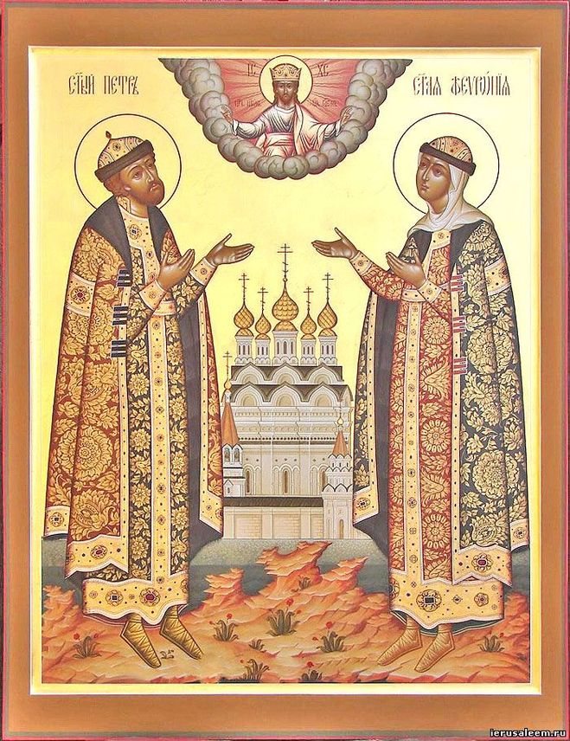
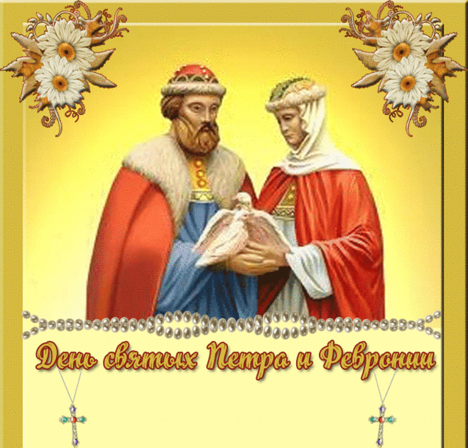
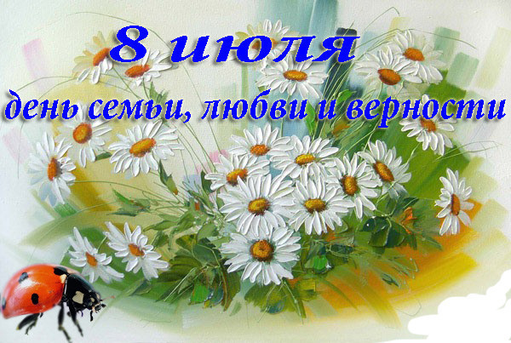
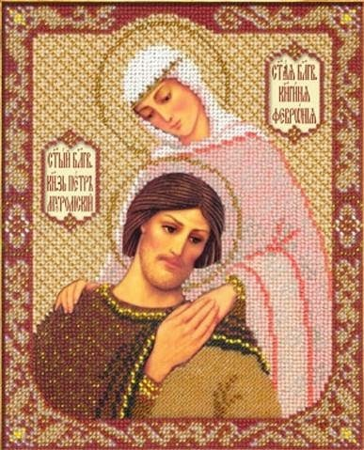
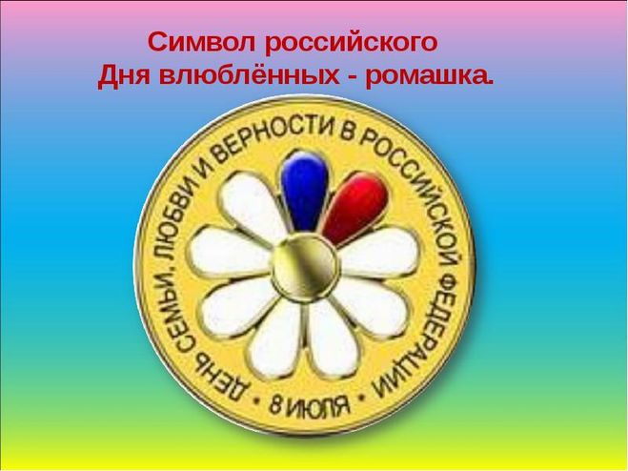
T: Let’s compare the traditions of Gr. Britain & our country. There is the same tradition of marriage and love in Russia. Now read the information about them and get ready to choоse the correct variant. But beforе reading try to translate these words or phrases (незнакомые слова и их последующий перевод появляются через проектор).
A ruler – правитель A boyar - боярин To be ill with unknown disease - страдать от неизвестного недуга To know the herbal medicine - знать целебную силу трав
To leave the throne - оставить трон The time of troubles – смутное время
To become monks - стать монахами God has heard their pray - бог услышал их молитву
Pyotr & Fevroniya
In the twelfth century in Murom there was a Russian ruler Pyotr by name. Pyotr was a good ruler but he was ill with unknown disease. Nobody could help him. But once he saw a dream about a poor girl Fevroniya who could save him. She lived in Ryazan’ and he immediately came there.
Fevroniya was an extremely beautiful and wise girl. She could understand animals and knew the herbal medicine. She promised to help Pyotr if he would marry her. Pyotr agreed of course. The only one problem prevented them from being happy – he was the ruler and Fevroniya was a poor girl. That’s why boyars were against her and asked Pyotr to leave the throne.
Pyotr had to choose between love and the throne. And he chose love. He took Fevroniya and they swam along the Oka having no any destination.
The time of troubles began in Murom then. Too many people wanted to become the rulers of the town. Some times later people from Murom arrived to Pyotr and asked him to return, to return with his wife. The legend says they did and ruled long and wisely. In a few years they became monks and asked God to die on one day and hour. God have heard their pray. On July 8, 1228 they died and were laid in different coffins. But in the morning of the next day they turned to be in one. Soon they became saints and the example of Christian marriage and love.

Choose the correct variant:
1. The Russian saints Pyotr and Fevroniya lived in
a. the 11th century BC b. the 11th century AD c.the 12th century
2. Pyotr wanted to find Fevroniya because
a.she was clever and beautiful b.he was ill c.he wanted to marry her
3. What did boyars ask Pyotr to do?
a. to marry Fevroniya b. to leave the throne c. to get out of Murom
4. Why did the people from Murom ask Pyotr to return?
a.the time of troubles began in Murom b. they missed Pyotr c.they missed Fevroniya
5. They died together
a. on the 18th of June, 1228 b. on the 8th of July, 1218 c. on the 8th of July, 1228
6. Nowadays Pyotr and Fevroniya are considered to be
a.the saints and the example of Christian marriage b. the most successful rulers ever
c.the most romantic people in the Russian history

1. Answer the questions:
Why St Valentine’s Day is more popular in Russia than St Pyotr and Fevroniya’s Day?
I think that St Valentine's Day is more popular in Russia than St Pyotr and Fevroniya’s Day because St Pyotr and Fevroniya’s Day is too religious and serious for all the Russians.
2. Read some phrases and try to express your ideas.
the story of St Pyotr and Fevroniya is not so beautiful and romantic as the story of St Valentine,
St Pyotr and Fevroniya’s Day is too serious and religious for all the Russians,
most people in Russia have never heard about St Pyotr and Fevroniya and their love.

