ТЕХНОЛОГИЧЕСКАЯ КАРТА УРОКА. WINTER. WINTER HOLIDAYS AND TRADITIONS 8-9 КЛАСС.
УЧИТЕЛЬ: АРБЕКОВА М.Ю. УЧИТЕЛЬ АНГЛИЙСКОГО ЯЗЫКА МБОУ СОШ № 19 Г. БЕЛОВО, КЕМЕРОВСКАЯ ОБЛАСТЬ
Тема |  | Winter. Winter holidays and traditions 8-9 класс
Цели темы: |  | Cовершенствование лексических и грамматических навыков, развитие умений монологической речи на основе предложенных ситуаций, контроль приобретённых умений и навыков. Развитие коммуникативной компетенции обучающихся, активизация лексики по теме: «Winter. Winter holidays and traditions 8-9 класс»
Задачи |  | Обучающие:  -практическое использование лексических и грамматических навыков по теме «Winter. Winter holidays and traditions»  - повторить и закрепить лексический материал по теме «Winter. Winter holidays and traditions»  - ввести новые лексические единицы и клише МФ  - практиковать навыки и умения чтения с извлечением информации  -практиковать использование грамматических времен в разных видах речевой деятельности;  -научить писать и составлять собственное мнение традициях.  Развивающие:  - развитие языковых, познавательных способностей учащихся, развитие эмоций школьников и готовности к коммуникации, ------развитие умений и навыков учащихся высказывать своё мнение и обобщать изученный материал по теме.  - создать условия для развития коммуникативных навыков через разнообразные виды речевой деятельности  - развивать исследовательские навыки: поиск, фиксация и обобщение информации;  - развивать умения смыслового чтения; умения прогнозировать содержание текста по ключевым словам, устанавливать смысловые соответствия при восприятии речи на слух;  Воспитательные:  - создание условий для воспитания культуры общения и поддержания интереса к учению, воспитание чувства уважения к традициям и культуре других народов, обучение познавательной деятельности с использованием иностранного языка.  - мотивировать на изучение иностранного языка;  - воспитывать толерантное отношение к друг другу  - воспитывать культуру поведения через освоение норм этикета;
Планируемый результат |  | Предметные умения  - умение читать с извлечением информации  - умение использовать ЛЕ в заданной ситуации и по данной теме;  - повторить и обобщить грамматические формы обозначения  - умение отвечать на вопросы по теме  - письменная речь, высказывание личного мнения  Личностные:  - умение устанавливать связь между целью деятельности и ее результатом  - формирование познавательных мотивов обучающихся взаимодействовать со сверстниками  Метапредметные  Регулятивные:  - осуществление самоконтроля  - оценивание правильности выполнения учебной задачи, возможности ее решения;  Познавательные:  - составление целого из частей; установление причинно-следственных связей;  - осознанное и произвольное построение речевого высказывания;  - осознанное и произвольное построение диалогического речевого высказывания с использованием плана;  - свободная ориентация и восприятие текста.  Коммуникативные:  - понимание речь учителя  - умение точно выражать свои мысли в соответствии с задачами и условиями коммуникации;  - планирование учебного сотрудничества с учителем и сверстниками
УУД |  | Личностные:  - формирование ответственного отношения к учению, готовности к саморазвитию и самообразованию  - формирование коммуникативной компетентности в общении и сотрудничестве со сверстниками  Регулятивные:  - осуществление регулятивных действий самонаблюдения, самоконтроля, самооценки в процессе коммуникативной деятельности на иностранном языке  Познавательные:  - построение логических рассуждений, включающее установление причинно – следственных связей: освоение ознакомительного, поискового чтения  Коммуникативные:  - формулировка собственного мнения и позиции, умения задавать вопросы; адекватно использовать речевые средства для решения различных коммуникативных задач
Домашнее задание |  | Write an article about your winter traditions.
Формы работы |  | Индивидуальная, парная, групповая
ЭТАПЫ УРОКА:

№ | Этап урока |  | Содержание этапа | Деятельность  учеников | Деятельность учителя | Формируемые умения Метапредметные результаты УУД
1 | Начало урока  Орг. момент Мотивация к учебной деятельности |  | Приветствие, активизация учащихся, создание предпосылок для вызова мотивации к работе на уроке. Введение в атмосферу иноязычного общения  T: Holidays are over, No more fun, Holidays are over,  School has begun! Good day, children!  Т: Good day, my dear friends! How are you? Great, wonderful, OK?  Look at the pictures, please. There are some things, which symbolize winter, winter traditions and holidays. Do you know these winter traditions and holidays ?  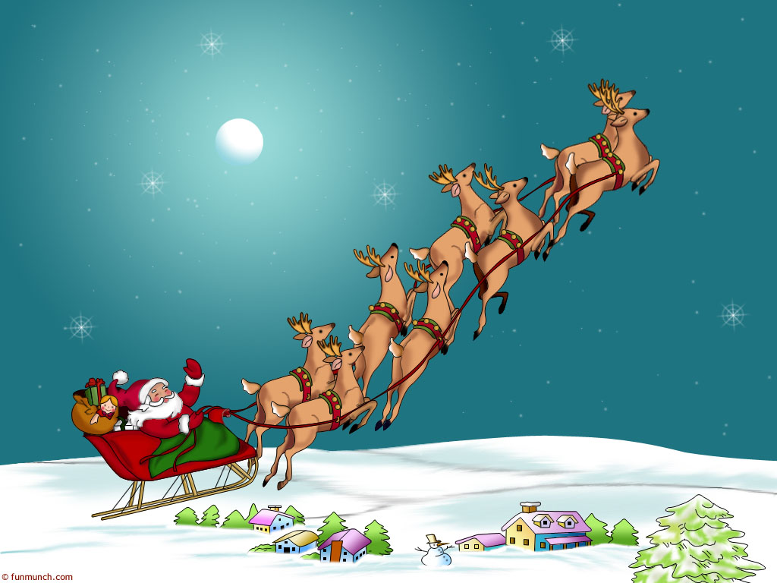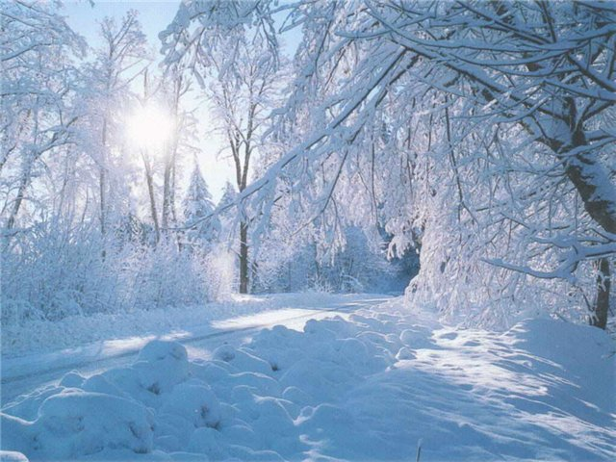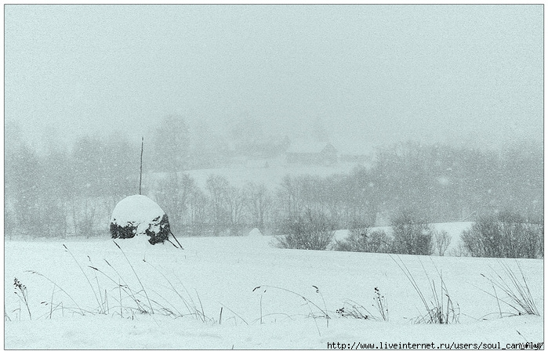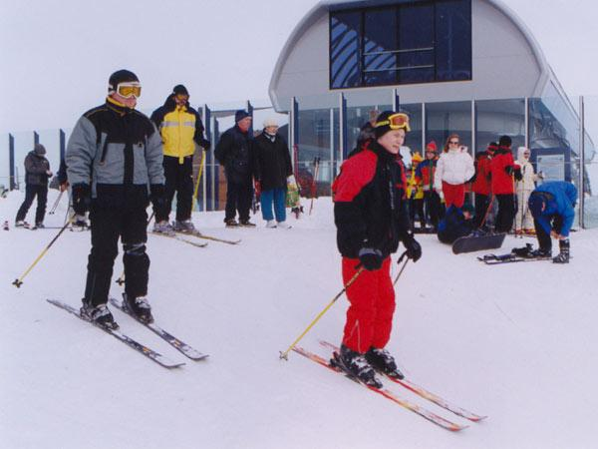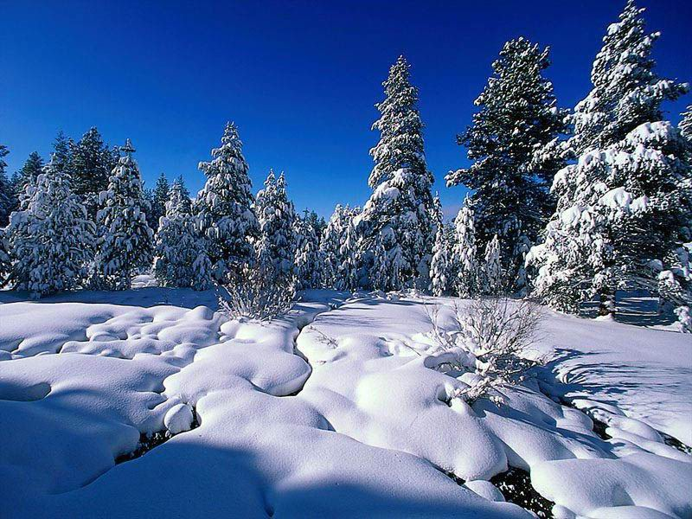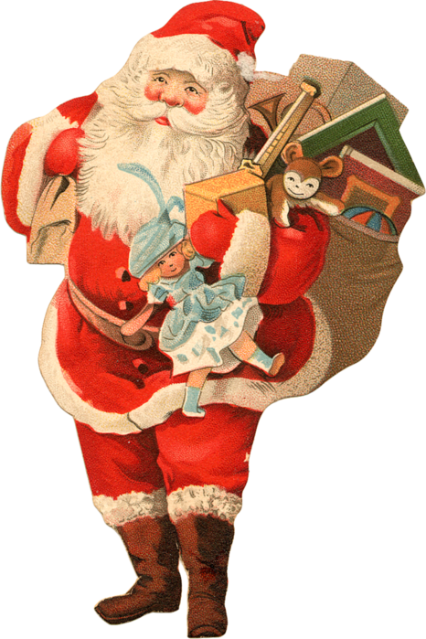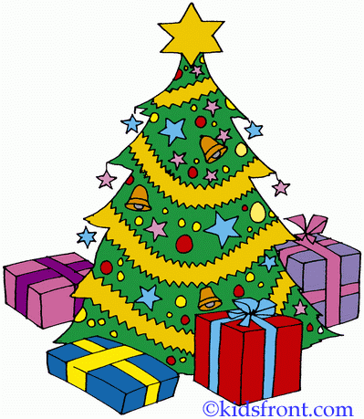  -Well done. And now we are going to talk about these winter traditions and holidays , great celebrations. I invite you to our talk on the theme «Winter. Winter holidays and traditions russian winter holidays». | Приветствуют учителя, настраиваются на работу на уроке, отвечают на вопросы, включаются в речевую деятельность, ответы c опорой на клише.  Учащиеся смотрят на картинку и выдвигают свои версии. | Активизирует  обучающихся, пытается настроить их на дальнейшую работу, привлекает внимание к картинке | Личностные:  -интерес к теме урока, его содержанию.  Регулятивные:  -осуществление самоконтроля  Познавательные:  – осознанное и произвольное построение речевого высказывания.  Коммуникативные:  - понимание речи учителя  – умение выражать свои мысли
2 | II.Актуализация знаний. а)фонетическая зарядка.  Фонетическая зарядка |  | На основе актуализации фоновых знаний обучающихся подвести их к раскрытию темы урока.  Активизация учащихся, создание мотивации к дальнейшей работе на уроке  Now listen to the poem and try to understand & guess it, please.  https://youtu.be/1mgdPtP7oE0  - Neath lucid scies of cleanest azure  The winter is rich and dazzling treasure  Her gorgeous rugs of snow are spread.  The wood is etched against them darkly…  -Do you like the poem? What do you know about Alexander Pushkin?  What is the poem about? | Учащиеся 1)слушают стихотворение А.С.Пушкина 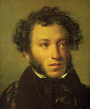 «Зимние утро» в записи; 2)пытаются понять содержание;  «Под голубыми | Подводит к раскрытию темы урока. | Личностные:  Умение высказать свои мнения  Познавательные:  – составление целого из частей.  Коммуникативные:  – понимание речи других;  - умение выражать свои мысли.  Предметные результаты:  – умение правильно понимать значение ЛЕ
3 | Речевая зарядка |  | Совершенствование навыков устной речи  T: Answer the questions. Are you ready to start?  Choose the words for definition “Christmas Day” and speak them.  Choose the words for definition “New Year's Day” and speak them. | Отвечают на вопросы учителя  соотносят ее с имеющимися у них знаниями,  работают с индивидуальными карточками | Задает вопросы  Проверяет правильность ответов, заданий | Регулятивные:  – саморегуляция и самоконтроль  Познавательные:  – осознанное и произвольное построение речевого высказывания.  Коммуникативные:  – планирование учебного сотрудничества с учителем и одноклассниками  Предметные:  – умение использовать ЛЕ в заданной ситуации
4 | Открытие нового знания. Развитие навыков чтения. |  | Развитие навыков чтения и тренировка лексического материала по теме на основе чтения текстов  Т: Christmas is celebrated all around the world. Each country has its own customs and traditions. Different countries celebrate in their own way including different dates, food which leads to a variety of diverse Christmas traditions around the world.  a)Pre-reading stage.  Let’s revise the main facts of these holidays  1.What can you say about the word “Christmas” (what does it mean?).  (This word is old English; it consists of Christ and Mass); we celebrate the « Mass», or church service, for Christ.  2. When do English people celebrate Christmas? (On the 25th of December)  3. When do people celebrate Christmas in Russia? (On the7th of January)  4. Who is the most important person for children on Christmas Eve in the USA and Britain? (Santa Claus/Father Christmas)  5. Who is the most important person for children in Russia? (Father Frost)  b)While-reading stage.  Read the texts  Christmas in Australia  In Australia, Christmas comes during the summer holidays. Some people hang wreaths on their front doors and go out Christmas carol singing on Christmas eve. Australians decorate their houses with Christmas trees, Christmas lights, tinsel, snowmen and glass baubles. They also decorate their homes with bunches of Christmas bush, a native Australian tree with green leaves and cream flowers. On Christmas Day, children receive presents in a stocking or under the Christmas tree. Children write letters to Santa Claus so that he knows what they would like for Christmas. Santa wears a thick red suit and travels in a sleigh pulled by reindeer.  Many Australians have a special meal on Christmas Day. Some people have cold meats and seafood and a Pavlova for dessert. A Pavlova is a soft meringue cake with cream and fresh fruit. On Boxing Day most people go to the beach with their friends and have barbecues and swim in the sea.  Read the information above and answer the questions.  What do some Australians hang on their front doors? 2. Where does Santa Claus leave the presents?  3. What does Santa Claus travel in? 4. Where do some people go on Boxing Day?  Rearrange the letters in these words and write them correctly on the lines. S F O O E A D - , R O L C A - , E I N D R E E R -, I G N C K O S T –  Christmas in Holland  For most children in The Netherlands, the 5th December is the most important day. This is when Sinterklaas (St. Nicholas) brings them their presents. On 5th December, children leave clogs or shoes by the fireplace and sing Sinterklaas songs. They hope that Sinterklaas will come when they are asleep and deliver some presents. They also believe that they will be left some sweets if they leave a carrot in their shoe for Sinterklaas's horse.  On the morning of St. Nicholas' Day, Sinterklaas travels to a city or town in The Netherlands. He wears red bishop's robes and travels with his servants called Zwarte Pieten (Black Peters). Sinterklaas rides on the roofs on his horse and a Zwarte Piet climbs down the chimney (or through a window) and puts the presents and sweets in the children's shoes. Some people go to church on Christmas Day and have a family meal. Many people also have a Christmas tree in their houses. Prettig Kerstfeest means Merry Christmas in Dutch.  Read the information above and answer the questions.  1. In The Netherlands, when does Sinterklaas bring the children their presents?  2. What vegetable do children leave in their shoe for Sinterklaas's horse? 3. Who travels with Sinterklaas? 4. What is 'Merry Christmas' in Dutch? 5. What colour are Sinterklaas's robes? a Purple b Gold c Blue d Red  Christmas in the United Kingdom  In the UK (or Great Britain), families often celebrate Christmas together, so they can watch each other open their presents. Most families have a Christmas tree in their house for Christmas. The decorating of the tree is usually a family occasion, with everyone helping. Holly, ivy and mistletoe are also sometimes used to decorate homes or other buildings. Most villages, towns and cities are decorated with Christmas lights over Christmas. Often a famous person switches them on. The most famous Christmas lights in the UK are in Oxford Street in London. Every year thousands of people go to watch the big 'switch on' around the beginning of November. Father Christmas or Santa Claus leaves presents in stockings or pillow-cases. These are normally hung up by the fire or by a child's bed on Christmas Eve.  In the UK, the main Christmas meal is usually eaten at lunchtime or early afternoon on Christmas Day. It is normally roast turkey, roast vegetables and 'all the trimmings' which means vegetables like carrots, peas, stuffing and sometimes bacon and sausages. It is often served with cranberry sauce and bread sauce. Dessert is often Christmas pudding. Mince pies and chocolates are often eaten as well! The dinner table is decorated with a Christmas cracker for each person and sometimes flowers and candles.  Now answer the questions below about how you celebrate Christmas.  1. How do you celebrate Christmas? 2. Do you have a Christmas tree in your house? 3. Describe below what a perfect Christmas tree looks like. What would you decorate the tree with? Try to be as creative as possible!  Christmas in India  Compared to other religious festivals, Christmas is quite a small festival in India. Midnight mass is a very important service for Christians in India, especially Catholics. The whole family will walk  to the mass and this will be followed by a massive feast of different delicacies, (mostly curries) and the giving and receiving of presents. Churches in India are decorated with Poinsettia flowers and candles for the Christmas Eve Midnight Mass service. Instead of having traditional Christmas Trees, a banana or mango tree is decorated. Sometimes people use mango leaves to decorate their homes.  Christians in Mumbai often display a manger in a front window. Also families go to great lengths to hang giant paper lanterns, in the shape of stars, between the houses so that the stars float above you as you walk down the road. Every household also makes sure that they have a stock of home made sweets ready for visitors. In India, Father Christmas or Santa Claus delivers presents to children from a horse and cart. He's known as 'Christmas Baba' in Hindi.  Read the information above and answer the questions.  1. What is Santa Claus known as in Hindi? 2. Name two trees that are decorated at Christmas in India. 3. What do Christians in Mumbai often display in their front window? 4. What do people in India give to visitors at Christmas time? a Sweets b Rice c Fruit d Chocolate  Christmas in Germany  A big part of the Christmas celebrations in Germany is Advent. Several different types of Advent calendars are used in German homes. As well as the traditional one made of card that is used in many countries, there are ones made out of a wreath of fir tree branches with 24 decorated boxes or bags hanging from it. Each box or bag has a little present in it.  Sometimes wooden frames, covered with coloured plastic sheets and with electric candles inside, are put in windows to make the house look pretty from the outside. Santa Claus or Father Christmas brings the presents on December 24th. December 6th is St. Nicholas' Day and "der Nikolaus" brings some small gifts, such as sweets and chocolate, to the children. He comes in the night between the 5th and the 6th and puts the presents into the shoes of the children, who usually place them by their doors on the previous evening. Christmas Eve is the main day when people in Germany exchange presents with their families. In German Happy/Merry Christmas is 'Frohe Weihnachten'. Carp or Goose are often served for the main Christmas meal. Stollen is a popular fruited yeast bread that is eaten at Christmas.  Read the information above and answer the questions.  1. What is the traditional Advent calendar made out of? 2. When does Santa Claus bring the presents in Germany?  3. When is St. Nicholas' Day? 4. Where does St. Nicholas put the presents? a In stockings b Under the tree c In shoes d In black sacks  5. What is 'Merry Christmas' in German? 6. What is 'Stollen'?  Christmas in France  In France, a Nativity crib is often used to help decorate the house. French cribs have clay figures in them, not wooden ones. During December, some towns and cities such as Marseilles have fairs that sell Nativity figures. As well as having the normal Nativity figures in them, French scenes also have figures such as a Butcher, a Baker, a Policeman and a Priest. In French Happy/Merry Christmas is 'Joyeux Noël'.  Yule Logs made out of Cherry Wood are often burned in French homes. The log is carried into the home on Christmas Eve and is sprinkled with red wine to make the log smell nice when it is burning. The main Christmas meal, called Réveillon, is eaten on Christmas Eve/early Christmas morning after people have returned from the midnight Church Service. Dishes might include roast turkey with chestnuts or roast goose, oysters, foie gras, lobster, venison and cheeses. For dessert, a chocolate sponge cake log called a bûche de Noël is normally eaten.  Read the information above and answer the questions.  1. What are the figures in French cribs made out of? 2. What is 'Merry Christmas' in French?  3. As well as having nativity figures in the cribs, what other figures are used? 4. What is the main Christmas meal called in France? 5. When is this meal eaten? 6. Write down three dishes that might be served at this Christmas meal. 7. What is normally eaten for dessert?  Christmas in Poland  In Poland, Advent (a time of waiting for the celebration of the Nativity of Jesus ) is the beginning of Christmas  time. It's a time when people try to be peaceful and remember the real reason for Christmas. Some people  also go to church quite frequently. During Advent, people also prepare their houses for Christmas. There's lots of cleaning and people wash their windows and clean their carpets very thoroughly. Everything must be clean for  Christmas Day!  Christmas Eve is a very important and busy day in Poland. Traditionally it is a day of fasting (not eating anything) and meat is not normally allowed to be eaten in any form. It is traditional that no food is eaten until the first star is seen in the sky! At the beginning of the meal, a large wafer biscuit called an 'Oplatek', which has a picture of Mary, Joseph and Jesus on it, is passed around the table and everyone breaks a piece off to eat.  If the Christmas tree hasn't been put up before hand, it is also brought in and decorated with tinsel, lights and glass decorations. Gold, silver and white chains resembling long, silver glittering hair is also hung on the tree and a star is placed on the top. Christmas Eve is finished by going to Church for a Midnight Mass service.  Read the information above and answer the questions.  1. What is Advent? 2. What is an oplatek? 3. In Poland, what is normally placed on the top of a Christmas tree?  a An angel b A star c A hat d A stocking  4. Unscramble the following words from the text: c u r h c h - , t d e r c a i o n o - , s f t i g n a - , l e s i t n - | Работают в парах, обсуждают прошешие каникулы,  переосмысливают информацию и выражают свое мнение  Выполняют задание, читают текст, тренируют приобретенные новые ЛЕ на практике | Учитель подготавливает учащихся к чтению текста, задает наводящие вопросы.  Организует работу с тем же текстом с целью выбора нужной информации (поисковое чтение), организует проверку понимания текста | Регулятивные:  – осуществление самоконтроля  Познавательные:  – осознанное и произвольное построение речевого высказывания Коммуникативные:  – планирование учебного сотрудничества с учителем;  – умение с достаточной полнотой и точностью выражать свои мысли в соответствии с задачами и условиями коммуникации.  Предметные:  – умение правильно понимать значение лексических единиц по теме;  – умение использовать ЛЕ в заданной ситуации;  – умение строить краткие высказывания с использованием опор.
 | Физкульт  минутка |  | Look at the window, Look at the door, Look at the ceiling,Look at the floor.Hands up, hands down,Hands on hips, sit down.Stand up, hands to the sides.Bend left, bend right. | Выполняют зарядку и задание на внимательность
5 | Активизация изученного материала по теме |  | T: Make 10 simple sentences:  Winter, Christmas, animals, in March, plants, sleep, a good time, for sports, in December, celebrate, begins, short, long, the weather, often, it snows, all, is covered, drifts, with snow, deep, lakes, rivers, ends, with ice, December, January and February, are covered  Fill in the gaps  A1… people look on Christmas as the time to celebrate the birth of Christ, but really the celebrations go back to the A2...of times. In A3…days , the sun meant so A4…to men that when it began to go lower each day till December 23 people worried for they thought the sun was dying out. They watched the sun and ate A5…keeping the food for the next year. On December 23 the sun stayed longer A6… the sky and gradually the days became longer and the nights shorter . When it happened the people were very A7 … . They felt they wanted to celebrate it .Now they A8…eat more –they were not afraid for their future any longer. Soon men began to understand the nature of the sun. But it became a tradition to celebrate the end of December with present and plenty of eating and drinking. There celebrations are now called Christmas.  A1 1) much 2) few 3) many 4) little  A2 1) eldest 2) earliest 3) latest 4) furthest  A3 1) these 2) that 3) this 4) those  A4 1) little 2) many 3) a lot 4) much  A5 1) more 2) less 3) much 4) fewer  A6 1) at 2) in 3) on 4) up  A7 1) upset 2) proud 3) happy 4) sad  A8 1) had to 2) could 3) must 4) should  Keys: many, earliest, those, much, less, in, happy, could. | Выполняют задания,  анализируют примеры, обсуждают правильные ответы  проверяют выполненные задания, анализируют ошибки | Предлагает составить простые предложения и выбрать правильный | Регулятивные:  – осуществление самоконтроля  – оценивание правильности выполнения учебной задачи, возможности ее решения.  Познавательные:  – осознанное речевого высказывания  Коммуникативные:  – умение с достаточной полнотой и точностью выражать свои мысли;  – планирование учебного сотрудничества с партнером
6 | Домашнее задание |  | Write an article about your winter traditions( 10-12 sentences) | Формулировать собственное мнение о традициях | Подводит итоги занятия, предлагает написать собственное мнение, cообщение
7 | Рефлексия |  | T: Dear, friends. Tell me, please, what did you know today?  T: Marks for the lesson…  Stand up, the lesson is over! Good bye! Good luck! | Оценивает результаты достигнутого на уроке, подводят итог урока, говорят, что было самым интересным, а что было самым трудным. | Подводит итог предлагает учащимся выбрать окончания фраз  NOW I KNOW…  NOW I CAN…  I WANT… | Регулятивные:  – осуществление самоконтроля ситуации.  Личностные:  -уважительное высказывание о творческой деятельности учащихся.  -умение поддержать, похвалить, корректно высказать мнение

